Software Requirements Specification

for

File Hosting

Version 1.0 approved

Prepared by Ahmed Abd El Gawad

Ahmed Hesham

Ahmed El Sayed Awad

Ahmed Mohamed Ahmed

Team 4A’s

27/3/2018

Table of Contents

Table of Contents ii

1. Introduction 1

1.1 Purpose 1

1.2 Intended Audience and Reading Suggestions 1

1.3 Product Scope 1

2. Overall Description 1

2.1 Product Perspective 1

2.2 Product Functions 2

2.3 Operating Environment 2

2.4 Assumptions and Dependencies 2

3. Functional Requirements 2

4. System Requirements 2

5. Other Nonfunctional Requirements 2

5.1 Performance Requirements 2

5.2 Safety Requirements 3

5.3 Security Requirements 3

5.4 Software Quality Attributes 3

6. Other Requirements 3

Appendix A: Glossary 3

Appendix C: Users of The System 3

# Introduction

## Purpose

The purpose of this document is to illustrate how we are developing the **File hosting** by showing the user interaction with the system through a list of functions/operations with their definition and pre/post conditions and a general scenario for each one, as well as the operations carried out by the system itself to improve its functionality. This document will be used as a reference for the development of the first version of the software and can also be used to estimate the costs and manpower needed.

## Intended Audience and Reading Suggestions

This document is written for the researchers, developers, project managers, marketing staff, users, testers, and documentation writers.

## Product Scope

**File hosting** is an Internet hosting service specifically designed to host user files. It allows users to upload files that could then be accessed over the internet only used by the user of the phone after a password or other authentication is provided. **Benefits:** uploading files on the internet, you can comment and like or share this uploaded file to social media, you can gain money from the downloads on the file that you uploaded. **Our objective** is to be the biggest file hosting server in the middle east and the world.

# Overall Description

## Product Perspective

Uploaders can gain money from uploading and getting your files downloaded due to that we will have community that will share interests and gain money.

## Product Functions

### Download

Any user can download files from our website with limited bandwidth or pay the needed fees to download with high bandwidth.

### Upload

Uploaders must have account to upload, free users can have capacity up to 10GB,premium users can have capacity up to 1TB and gain money from downloads of their files.

### Share

You can share any file of yours and you can share the files of other user but with taking permission.

## Operating Environment

Any user that have browser on his/her operating system can access our website and use it smoothly.

## Assumptions and Dependencies

In the future, our website is going to be more social and open that you can access by other accounts on other websites like Facebook, Twitter, etc. There are going to be two choices for uploading, you can upload just to save the file on the cloud or to share with others so you can gain money or just to make others able to use it.

# Functional Requirements

## Sign up:

We get the needed information from the user and save them in the database.

## Login:

The user enters the needed data then we check these data from the database to verify.

## Upload file:

You can upload the data from you PC to the website to either keep them private for your self or to make other users check them.

## Access file:

You can access any file on the website to check wither it is suitable or not by pressing on the link and we get to you from the database.

## Share file:

You can put the file on your account so your followers can access them easily.

## Download file:

You can access the file you downloaded easily from your PC offline.

## Review file:

The review every user put it we show its average on the file page to indicate its quality.

## Report file:

We check the reports we get from the users to guarantee the comfort of the users and then the admin decides wither to ban this file or not.

## Block user Request:

We also get requests to block users and also the admin decides to block the user or not.

# System Requirements

We will use Red Hat Linux as our operating system, and for server and http service we will use apache tom cat. To provide the best service we will use in hardware, servers with large capacity.to secure our user data we will have backup drives to backup all the data of the user.

# Other Nonfunctional Requirements

## Performance Requirements

We provide fast response time that when the user ask for any function on the website he will get a fast and right response for his needs. Since we provide a world wide service we designed our systems to maintain its stability with millions of users using it in the same time.

## Safety Requirements

The most damageable parts of the hardware system are hard drives so we have backup hard drives.

And regulations that if any data loss happen we will pay the user for this.

## Security Requirements

We provide the user with authentication in the same time he can choose the username and password he wants. We have high level of user privilege that its guaranteed to keep the privacy of his account from others so no one can access his data. Every user has his copy rights on the files he uploaded so no one can use them by any unsatisfied way to the original uploader. Since we are a file hosting website we provided the maximum-security systems to protect the data of the user.

## Software Quality Attributes

We considered many attributes in designing our website like adaptability: our website can be used by any device or operating system it maintains its functions on any case. Maintainability: to keep our systems updateable and not to affect our systems while maintaining it we kept it maintainable as we can. portability: the user can access our website from any device that has access to the internet.

Testability: to not be faced with any unexpected behaviors our website put under many tests before uploading it or making any changes.

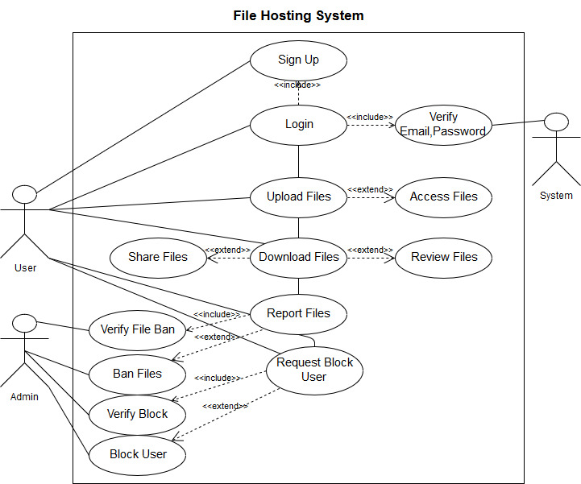

**6.Use Case**

**General Scenario:**

user goes to the FTP website:

* We provide sign up option to give opportunity to new users to join our website
* The users can always login to the website from any browser or device by writing the user name and the password
* You can access any file only by clicking on its link
* Uploading is an easy operation you can click on upload file button and choose the file you want from the pop-up window that view the files from your PC
* Sharing is an option for you just by clicking share button and completing the requirements
* You can keep your favorite files on your PC by downloading them by clicking Download button
* After checking the content of any file you can review any file and giving it the rate you think it deserves
* If there is inappropriate content in any file you can report that file
* The users that show inappropriate behavior you can ask for blocking them by sending block request

**Detailed Scenario:**

**Sign Up**

1 – The user presses the sign-up button

2 – The user fills his first name, last name, email, password and visa number

3 – The user receives a verification email

4 – The user clicks on the link in the email

5 – The user now allowed to access his account

**Login**

1 – The user goes to the home page

2 – The user clicks on the login button

3 – The user enters his username or email, and password

4 – He goes to his home page if he entered valid information

5 – A pop up window asks him to reenter the information in case any of them wrong

**Download Files**

1 – The user presses the link for the file he wants to download

2 – The user clicks the download button under it

3 – A pop-up window to write his pin

4 – The system checks the validity of the users pin

5 – If it’s wrong it pops-up the window to try again for three more times

6 – If it’s right a pop-up window shows up to choose where to download on his machine

7 – The user choses the folder to download in and press ok on the pop-up window

**Upload files**

1 – The user presses the button that labeled upload a file

2 – A pop-up window to choose the file from the user’s machine

3 – The user chooses it and click ok

**Access files**

1 – The user writes in the search the name of the file he wants access and chooses the type of the file a photo, video, word etc.

2 – A window with all the files that have a similar or close name

3 – The user clicks in the link he wants

**Share files**

1 – If it is a free file the user just presses the button labeled share

2 – If it’s not free he needs to contact the original uploader first to take his permission and make any arrangements with him which he can do by click on the contact the owner button

**Review files**

1 – After accessing a file the user can review it by a grade from one to ten pressing review button

2 – The user also can write a comment by clicking the comment button

3 – The user will get a notification with any response to his comment

**Report Files**

1-The user has the option to make a report on any file if it has any inappropriate content by accessing the file link.

2-press the report button.

3-choose why he made the report.

4-he can add a comment on the report.

5-press ok to the send the report to the admin.

**Detailed Use-case with tabular description:**

Sign up

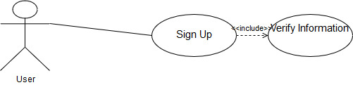

|  |  |
| --- | --- |
| Use – case name | Sign up |
| Trigger | The user selects to register in the web site as free/premium user |
| Pre-condition | The user fills his information (name, age, email, password) |
| Post-condition | The user has profile in our website but need to access validation email. |

Login

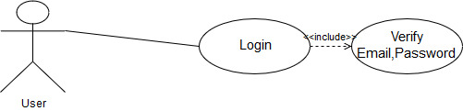

|  |  |
| --- | --- |
| Use-case name | Login |
| Trigger | The user selects sign in from homepage |
| Pre-condition | The user enters his email and password |
| Post-condition | The user can access his profile |

Upload Files

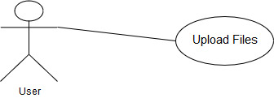

|  |  |
| --- | --- |
| Use-case name | Upload Files |
| Trigger | The user clicks on button upload a file |
| Pre-condition | The user selects the file that he wants to upload |
| Post-condition | The file gets uploaded |

Download Files

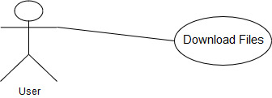

|  |  |
| --- | --- |
| Use-case name | Download Files |
| Trigger | The user selects the file to download and click on link. |
| Pre-condition | The user enters the captcha and gets verified and set location for downloaded file. |
| Post-condition | The file gets downloaded |

Report Files

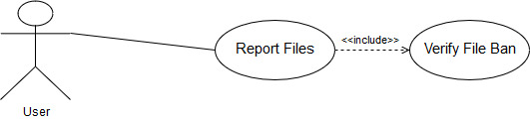

|  |  |
| --- | --- |
| Use-case name | Report Files |
| Trigger | The user selects report files |
| Pre-condition | The User select why he reported the file and can leave a comment |
| Post-condition | The file gets verified and if the file is an inappropriate the file could be banned. |

Request Block Users

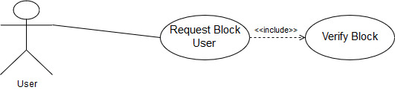

|  |  |
| --- | --- |
| Use-case name | Request Block User |
| Trigger | The user selects Request Block |
| Pre-condition | The User select why he reported the User and can leave a comment |
| Post-condition | The user gets verified and if the user uploaded a lot inappropriate files the user gets blocked. |

# 7.Sequence Diagrams

Login

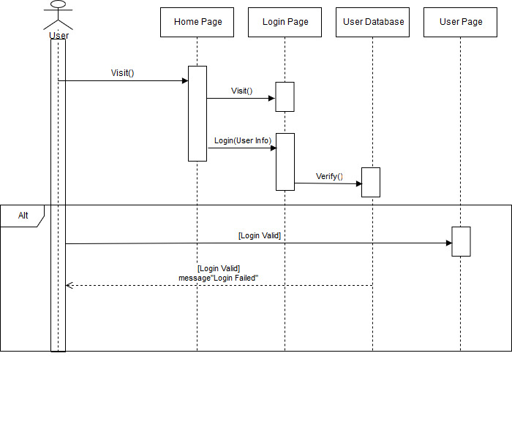

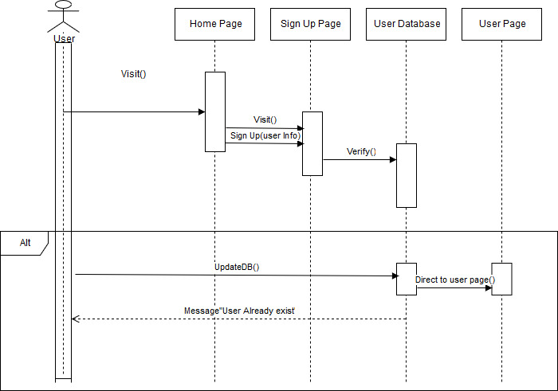Sign Up

Download

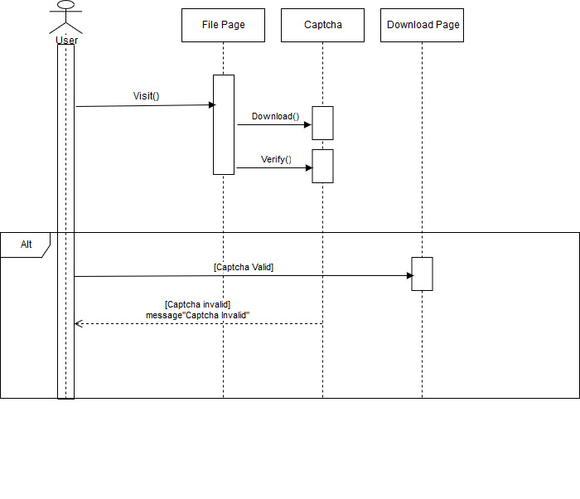

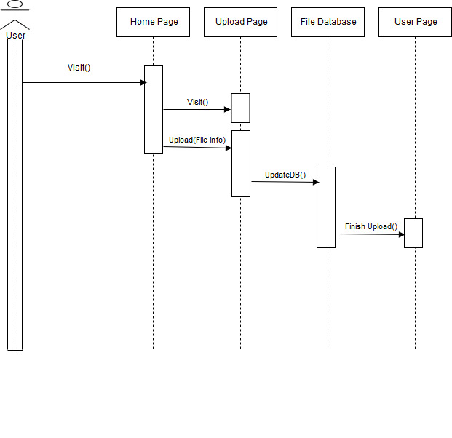Upload



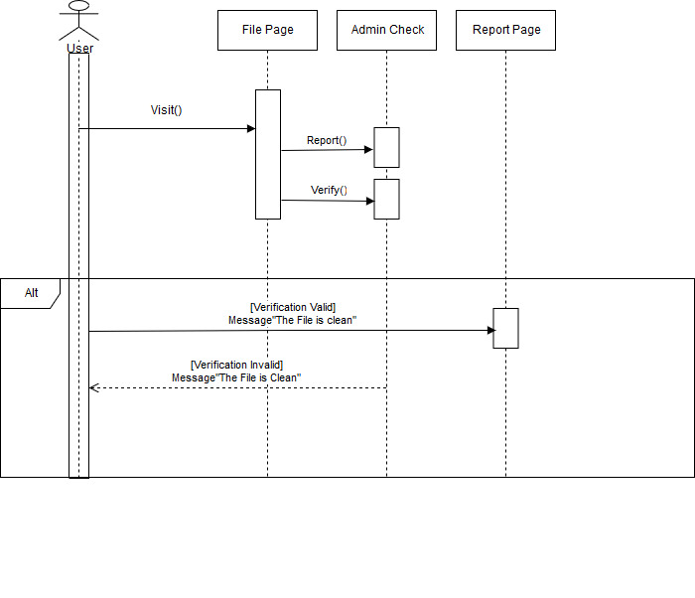Report Files



**8.Activity Diagram**

Upload

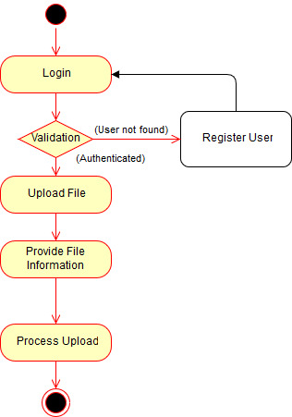

Share Files

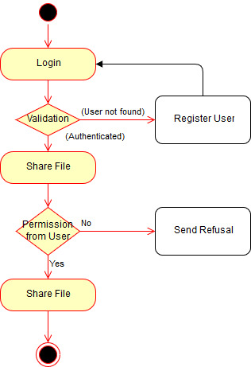

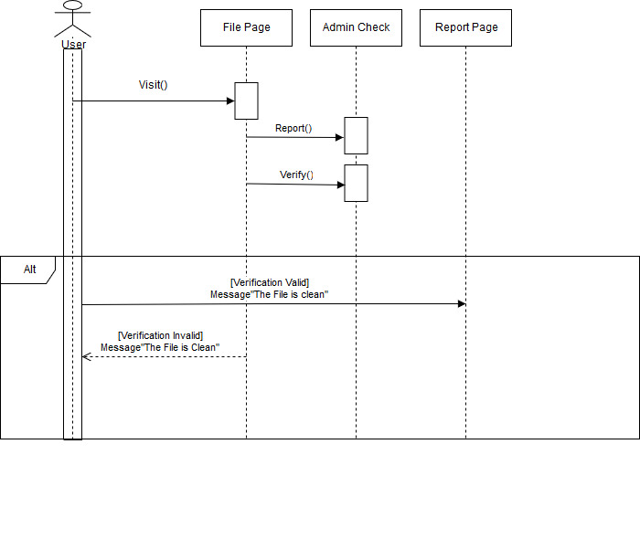Report Files

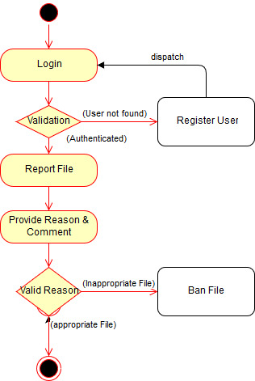

# 9.Context Diagram

# 10.Data Flow Diagram

# 11.Entity Relation Diagram

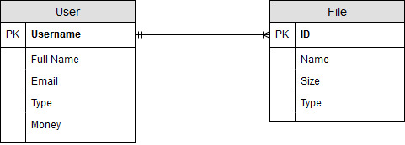

# 12.Other Requirements

|  |  |
| --- | --- |
| Term | Description |
| Functional requirement | The main operation that the user can perform. |
| Non-functional requirement | Quality attributes to improve the functionality of the system |
| Server | is a computer program or a device that provides functionality for other programs or devices, called "clients". |
| Linux OS | Linux is a family of free and open-source software operating systems built around the Linux kernel. |
| Bandwidth | the rate of data transfer. |

**Appendix A: Glossary**

Appendix C: Users of The System

|  |  |
| --- | --- |
| Term | Description |
| User | The user is a general term that includes everyone using the mobile applications such as the downloader, uploader and the admin. |
| Actor | Anyone who can perform operations on the system (downloader/uploader/programmer/admin/) |